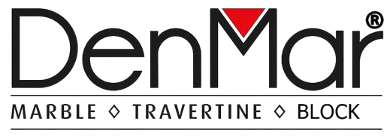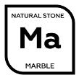

www.denmarmarble.com

| **Collection Name** | **Calacatta Copper** | **Quarry Location** | **Mugla / TURKEY** |
| --- | --- | --- | --- |
| **Stone Type** | **Marble** | **Available Surface Type** | **Polished Honed  Brushed** |
| **Color** | **White & Copper** | **Shade Variation** | **Modorate** |

| Available Types | Size or Models | Application Areas | Transport Type |
| --- | --- | --- | --- |
|  | *Group Pricing  (small and big blocks together)  *Selection Pricing  (large size blocks for slabs) |  | In container |
|  | 20 mm Random Size Slabs  30 mm Random Size Slabs |  | Wooden Bundle |
|  | 3”*6” (75x150 mm) (in special boxes)  4”*12” (100x305 mm) (in special boxes)  12”*12” (10x305x305 mm)  12”*24” (10x305x610 mm)  16”*24” (10x406x610 mm)  24”*24” (10x610x610 mm)  24”*48” (20x610x1220 mm) |  | In wooden crates |

| Descriptions:   * [Natural stones](https://www.pietramosaic.com/products/), marbles, and travertines have their own colour palettes, textures, and shades by their nature. It has both natural and humanmade reasons. First one is natural. Because of the differences between the mine veins. The same stone could show some differences when it comes to different stone veins. Even they are extracted from the same quarry. Second one is humanmade. Because of the cutting skills, the stones look different if it is Vein-Cut or Cross-Cut. When we produce mosaics, our experient production team gives attention to these causes, and make the mesh according to them. |
| --- |